**Phase10-Quality Assurance Test**

1. Created Objects:

**For the patient object:**

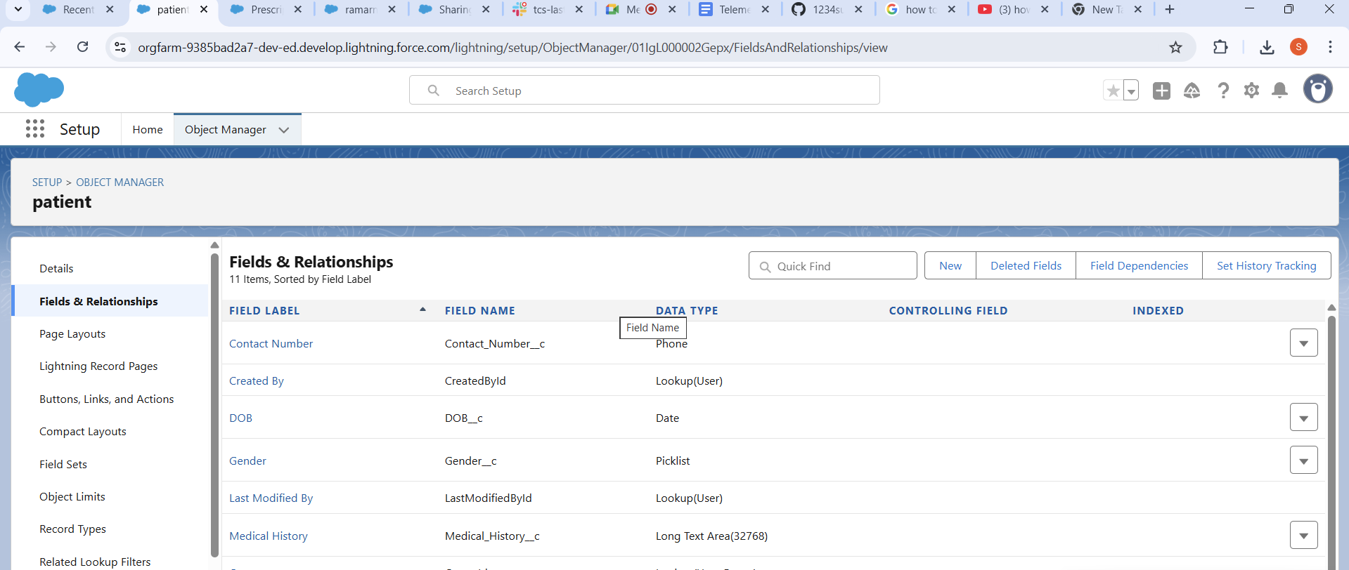

This is how it looks like

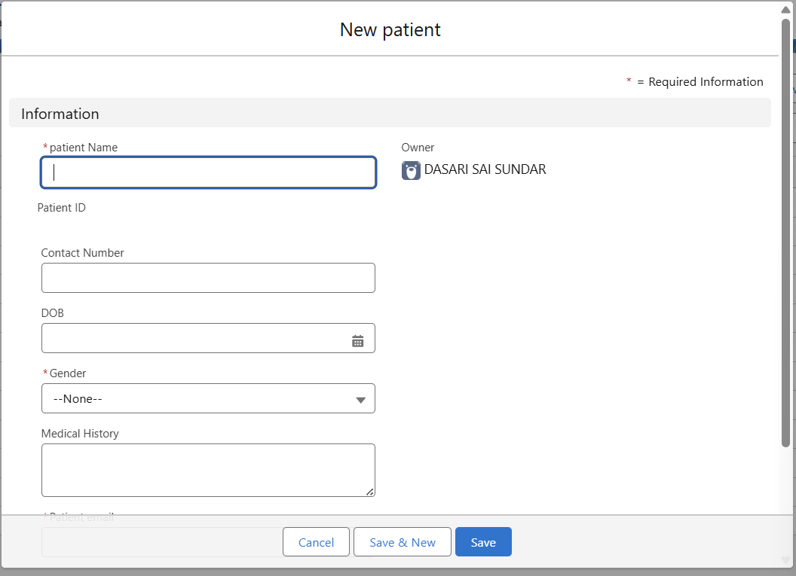

**For the doctor object:**

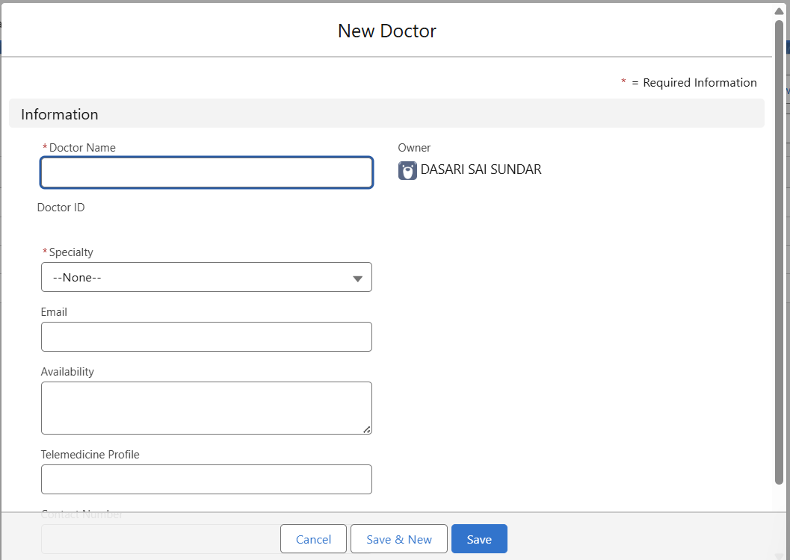

**For teleappointment object:**

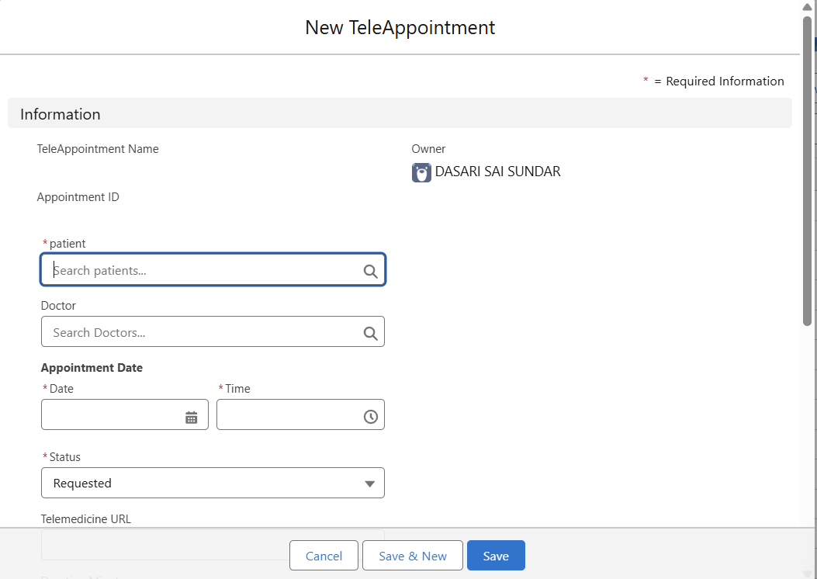

**For the Prescriptions:**

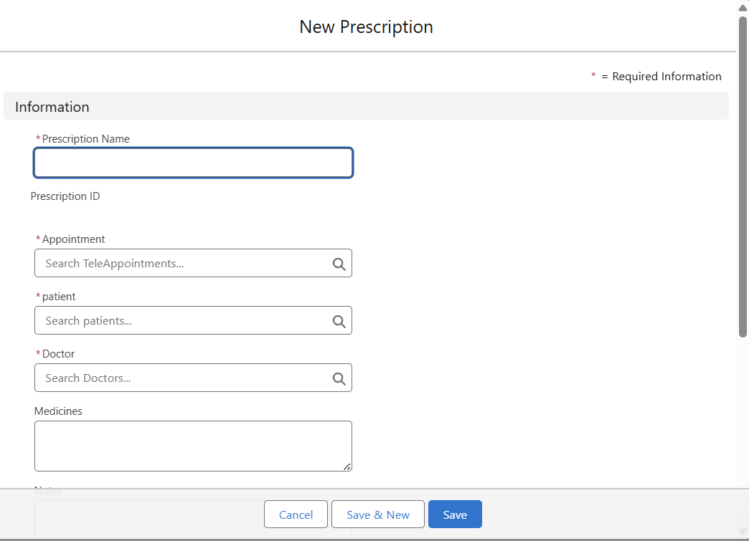

Every field created is successfully added in the Platform objects.

1. Record Types: The is the custom Online Consultation

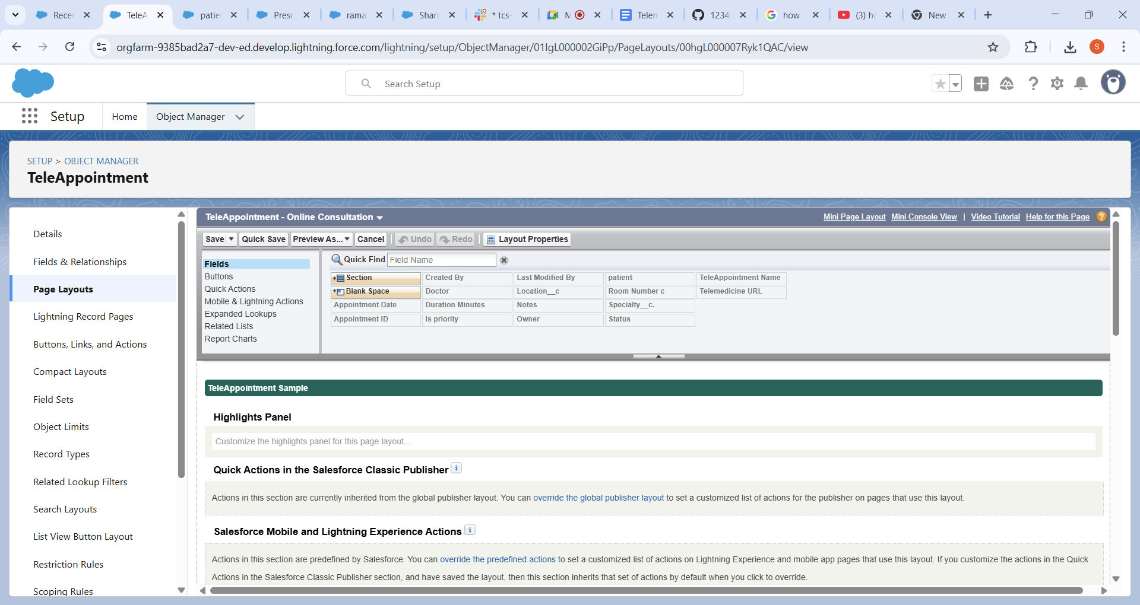

This is Appear on the screen

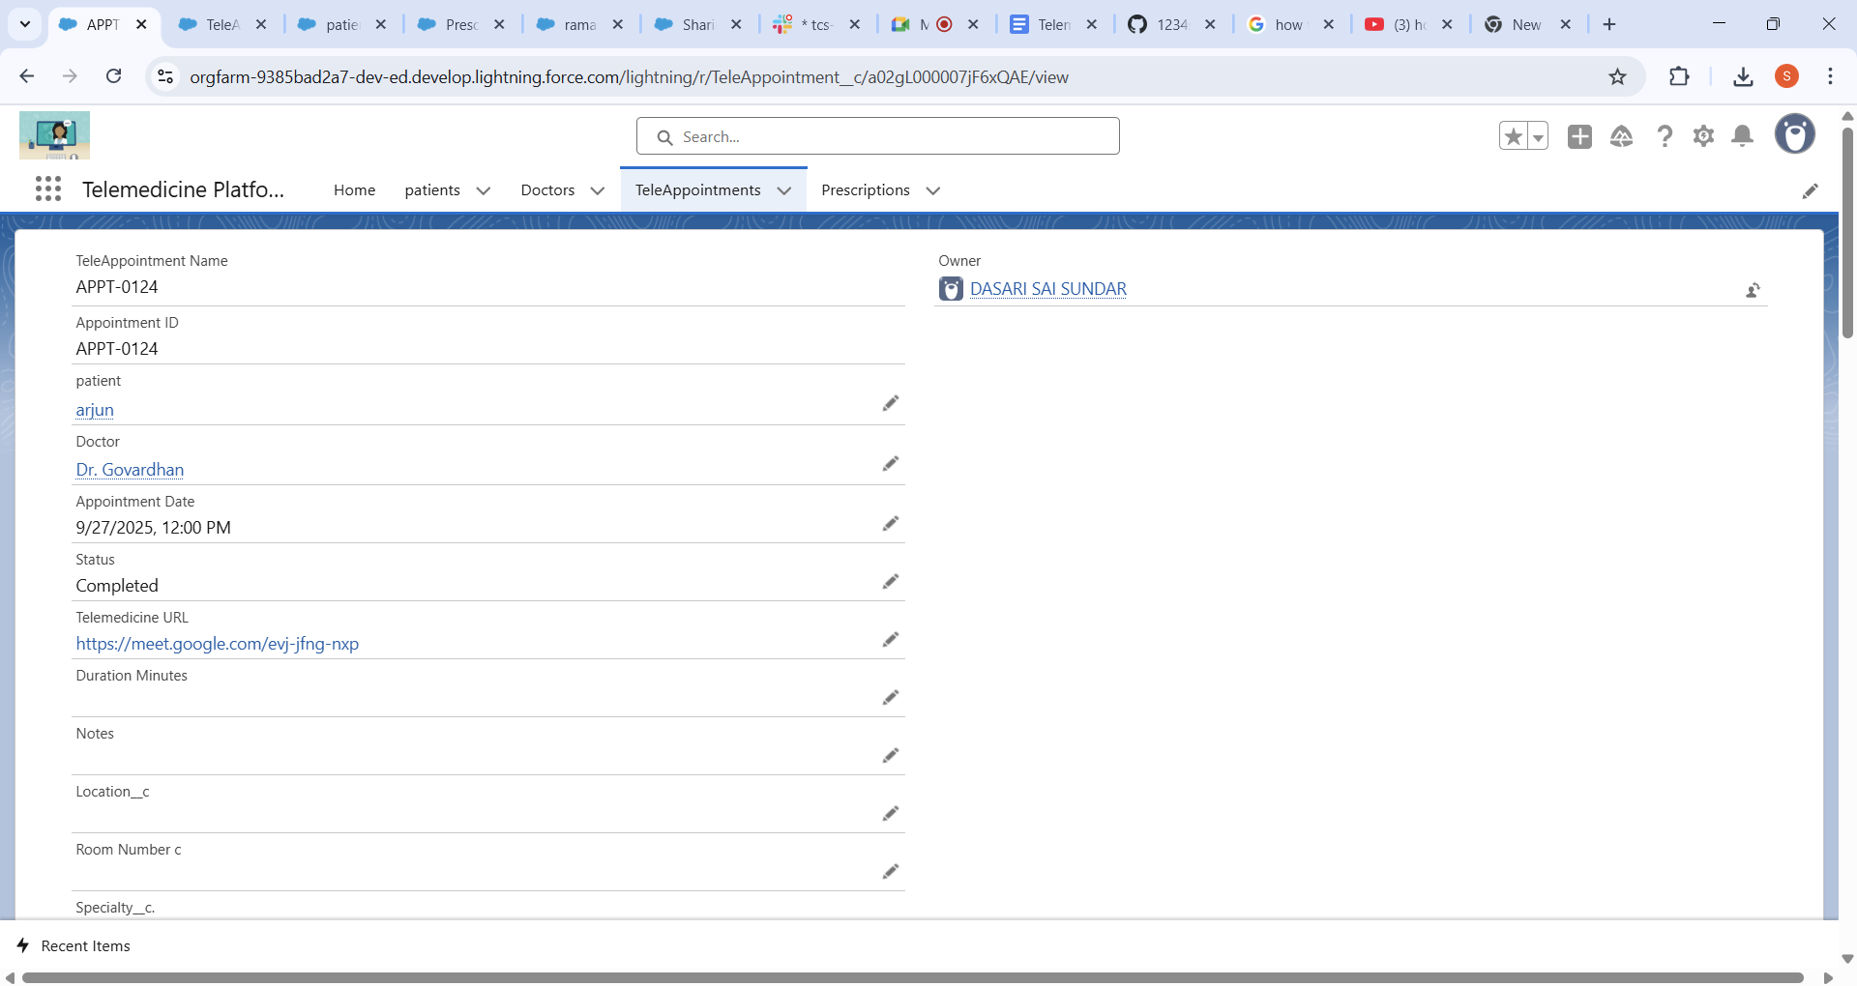

1. **Process Automation:**

**a.Validation Rule: TM_No_Past_Appointments**: This rule prevents a user from creating a TeleAppointment with a date that is in the past. It uses the formula.

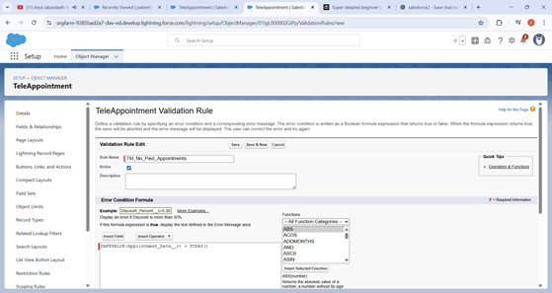

Process Automation**🡪Testcase1:** I have created the appointment in past means yesterday.

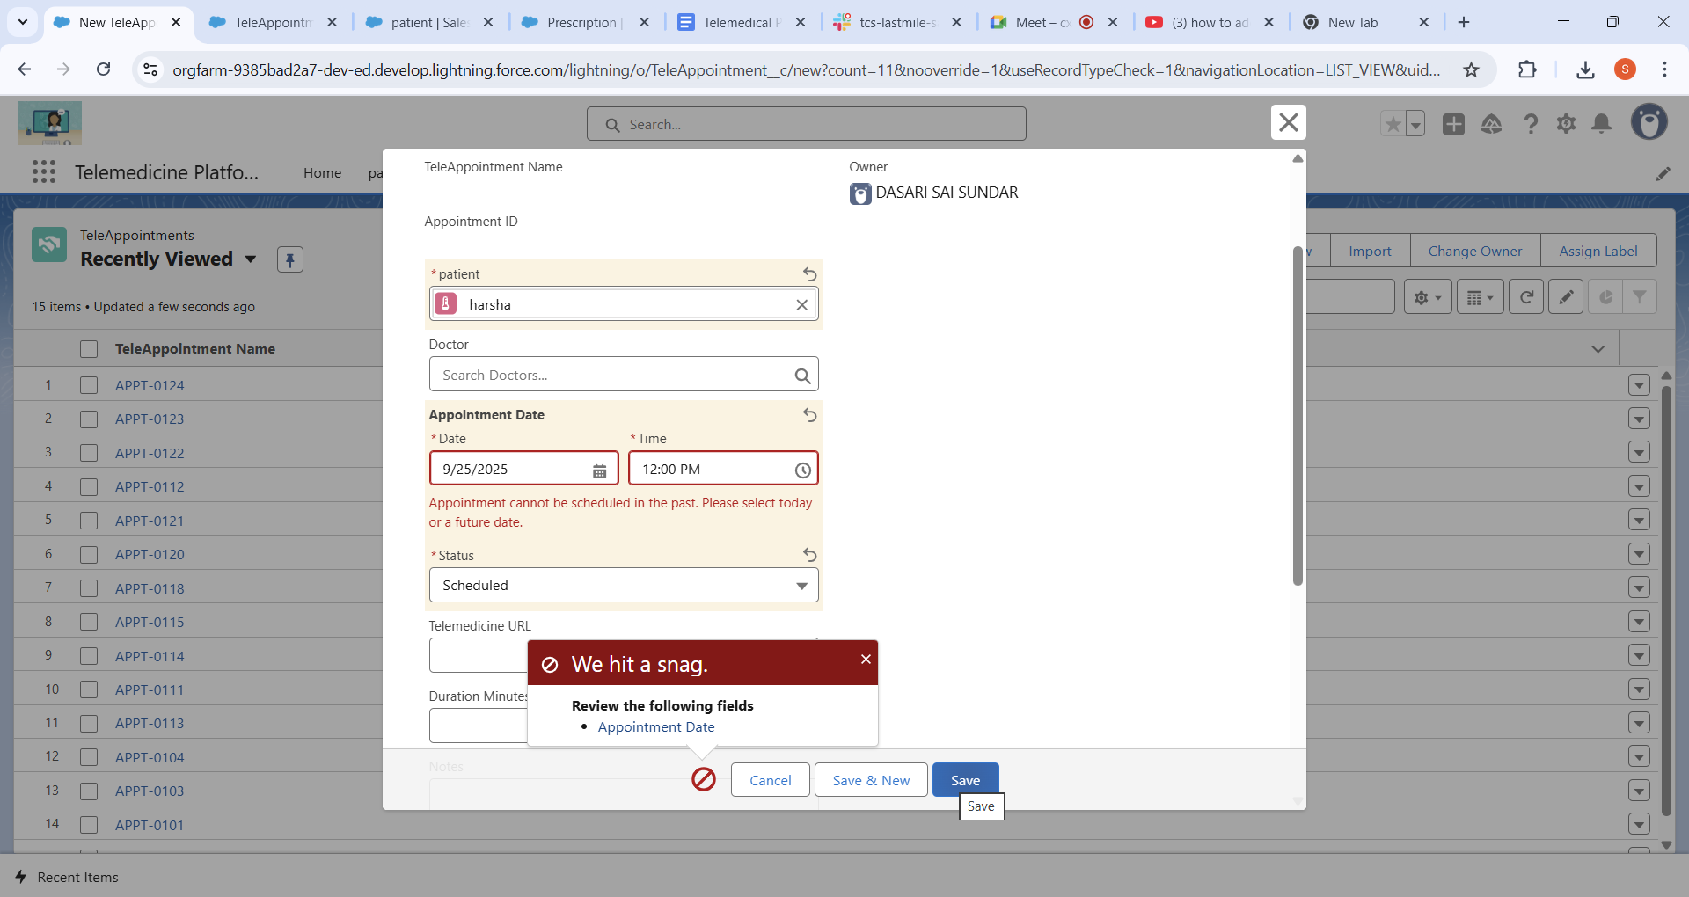

Process Automation **🡪Testcase2**:Give the date as the 2 tomorrow its saved successfully

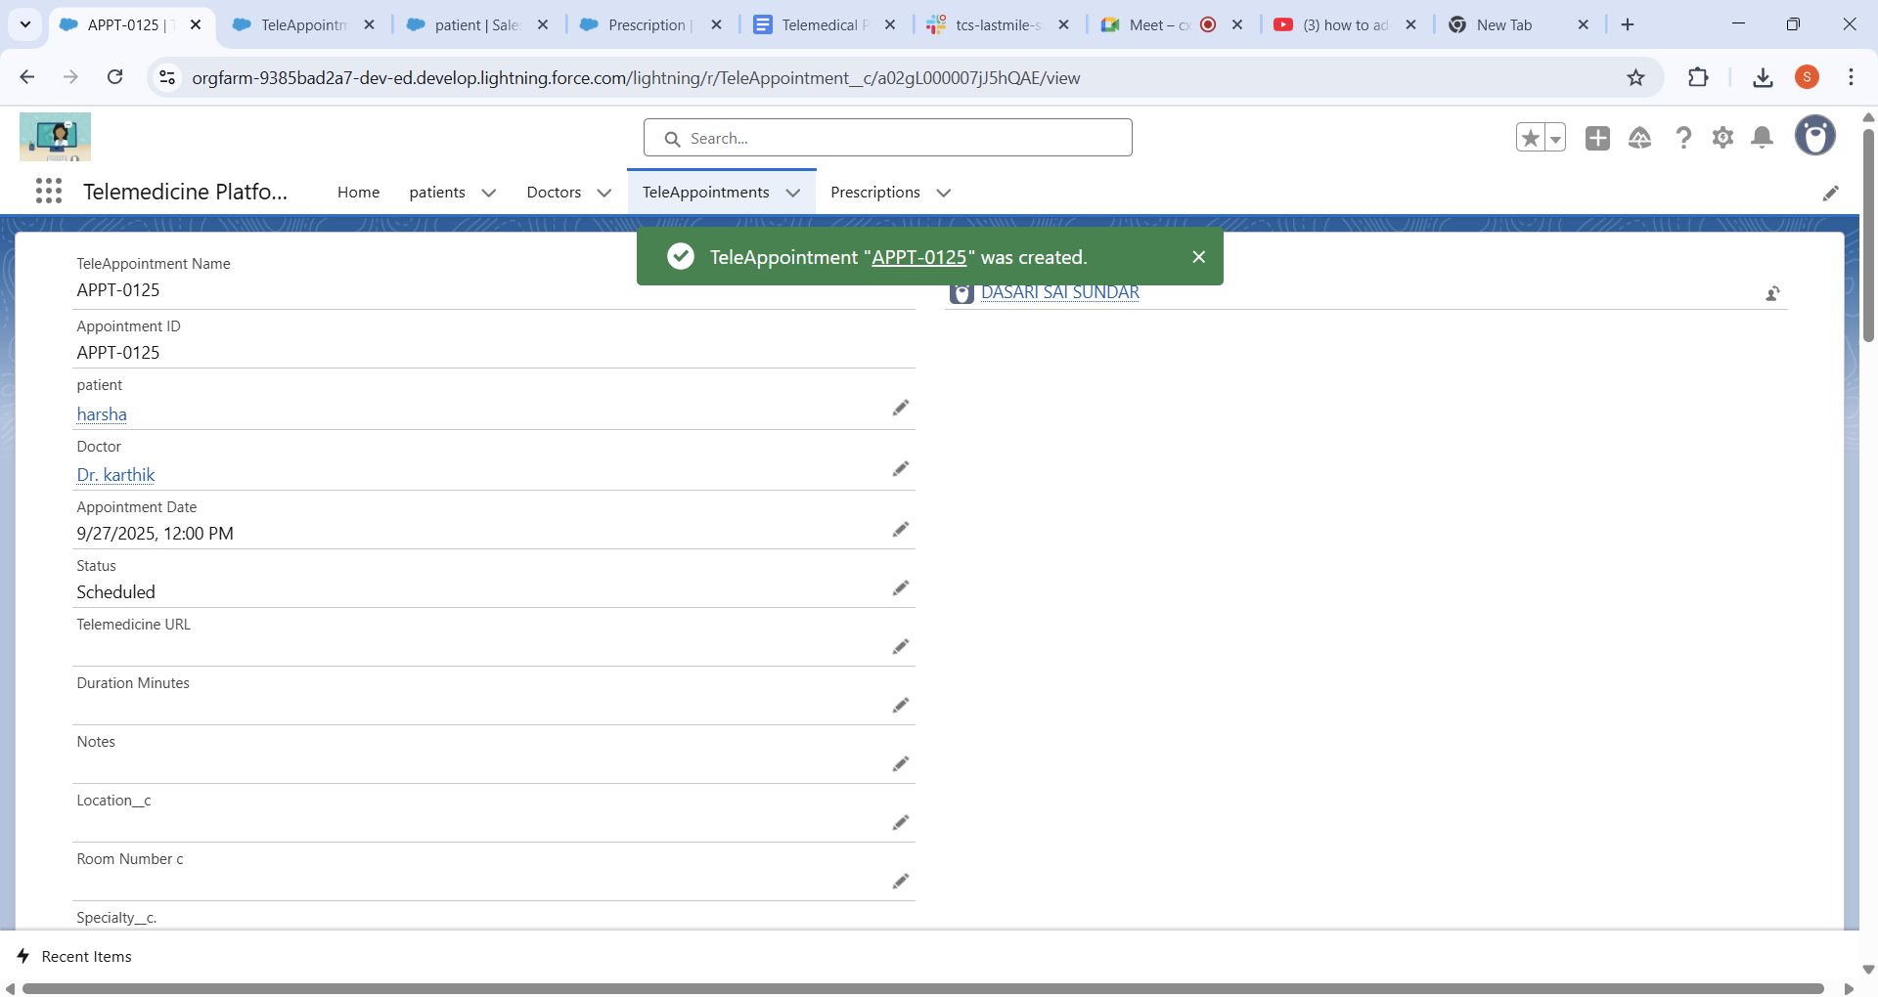

**b. Age Must be between 1-120:**

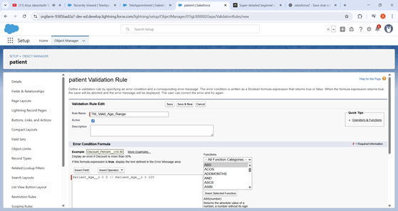

Process Automation **🡪Test Case1:I give the patient age in 129:**

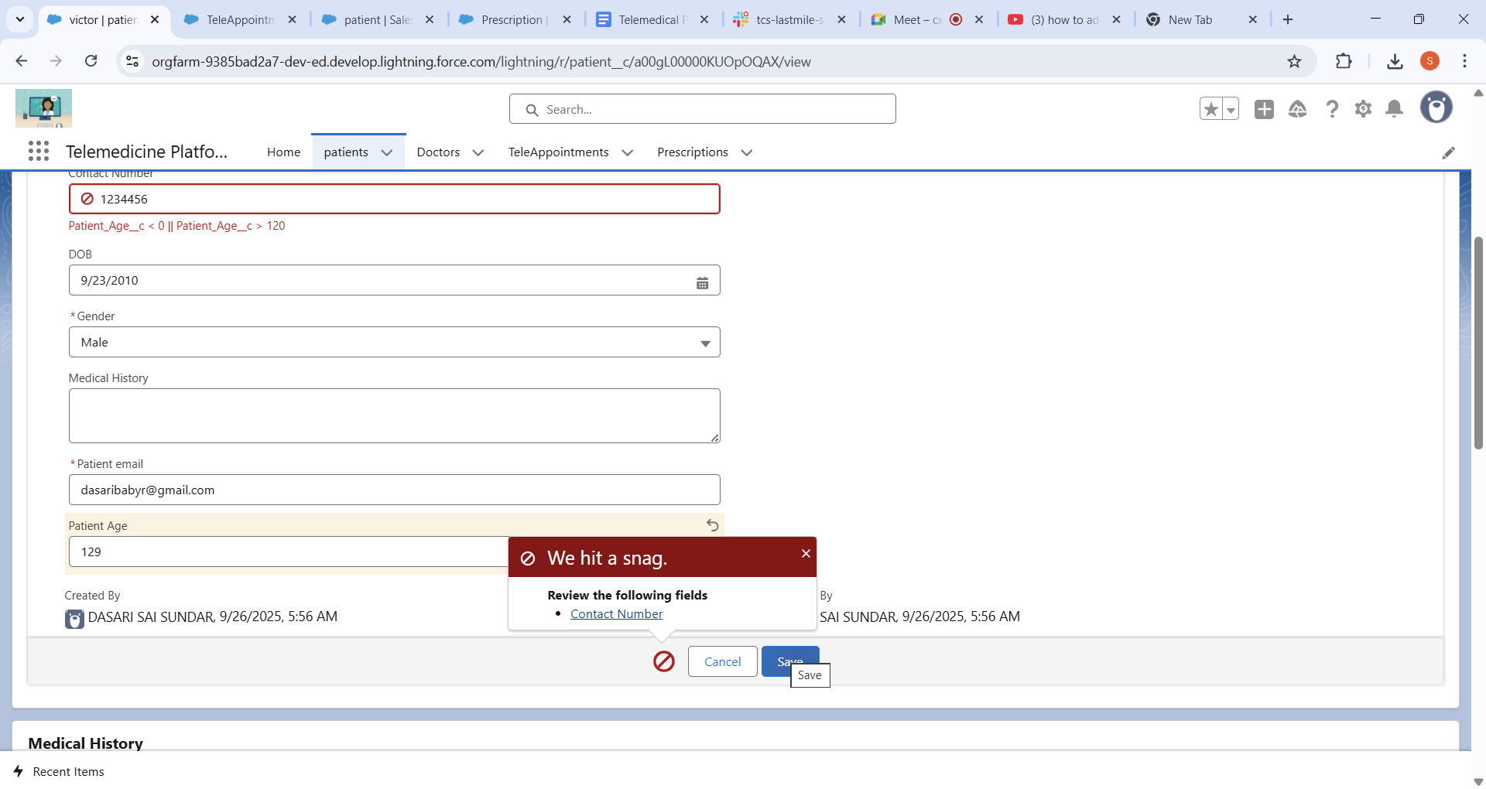

Process Automation **🡪Test case2:I have given the patient age in 200:**

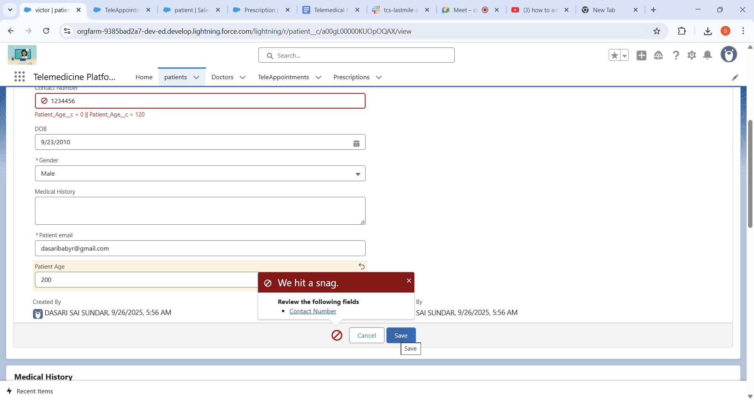

Process Automation **🡪Test Case3: Given 20 as the age and Testcase Passed:**

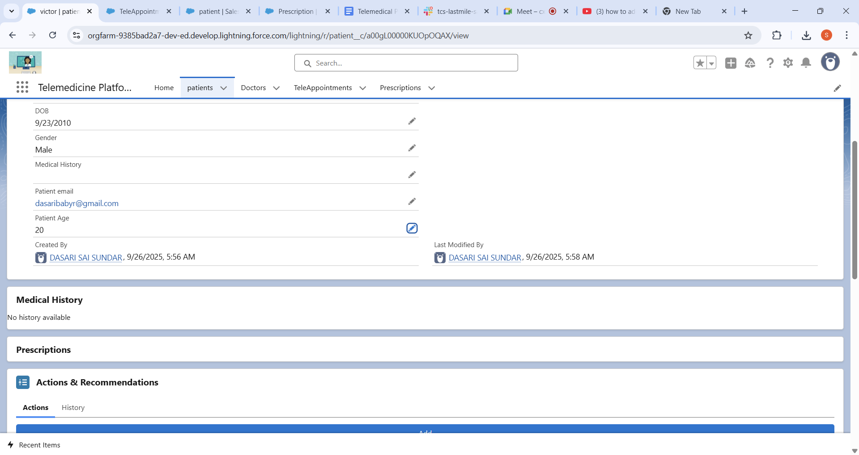

1. Lightning Email Template:

Created the Email Template For the Appointment Confirmation:

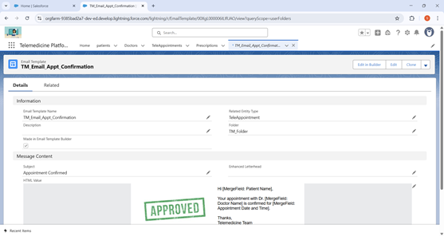

Lightning Email Template 🡪Test case1:

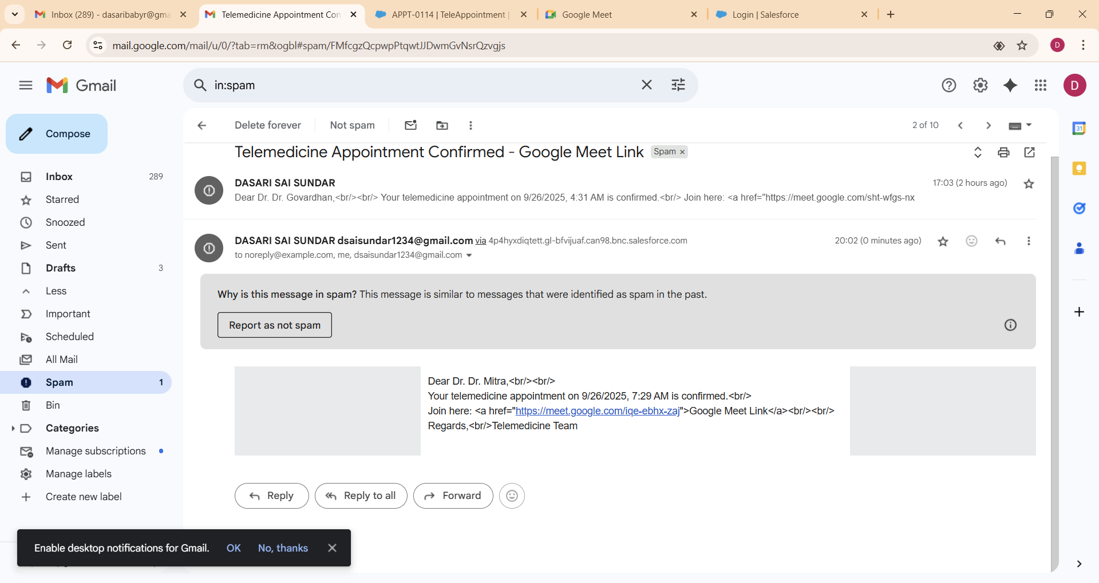

1. Workflow Rules Validation:

This work flow uses the Above Email Template. The doctor can make the approval in his org account then the email Approval confirmed.

Workflow Rules Validation 🡪Test case1:

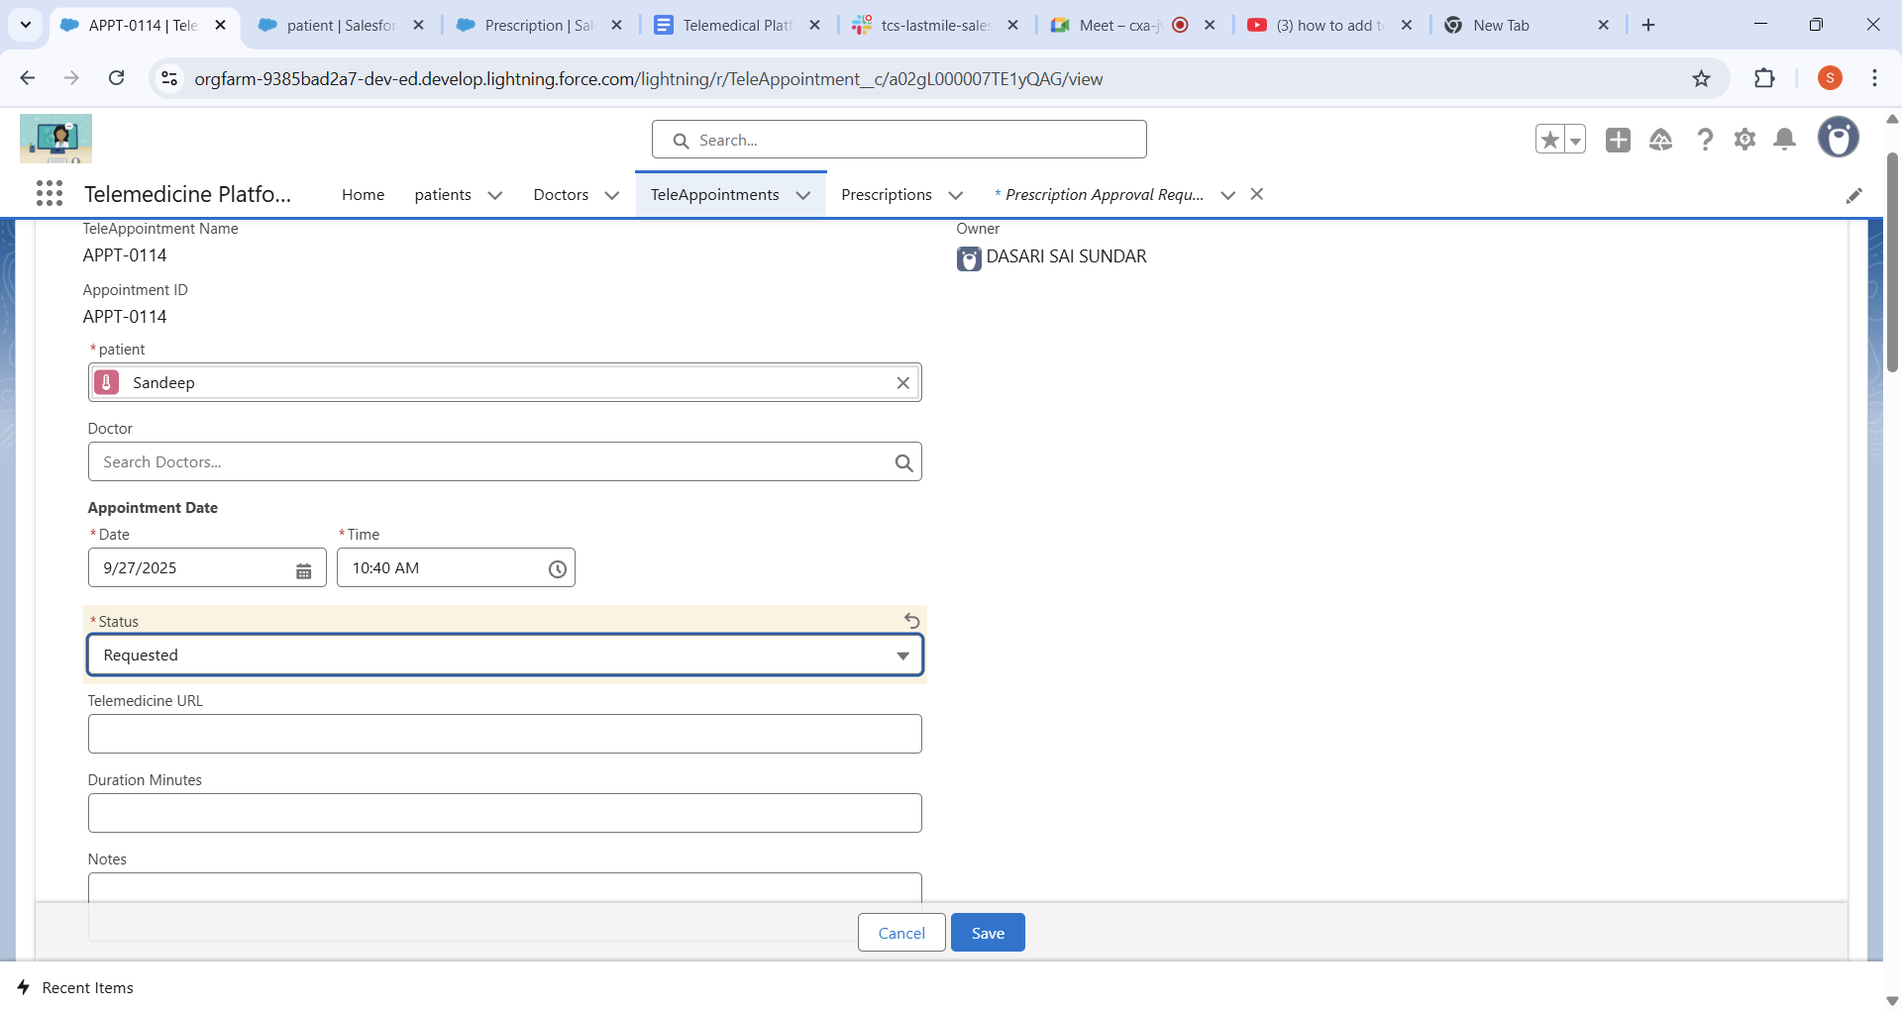

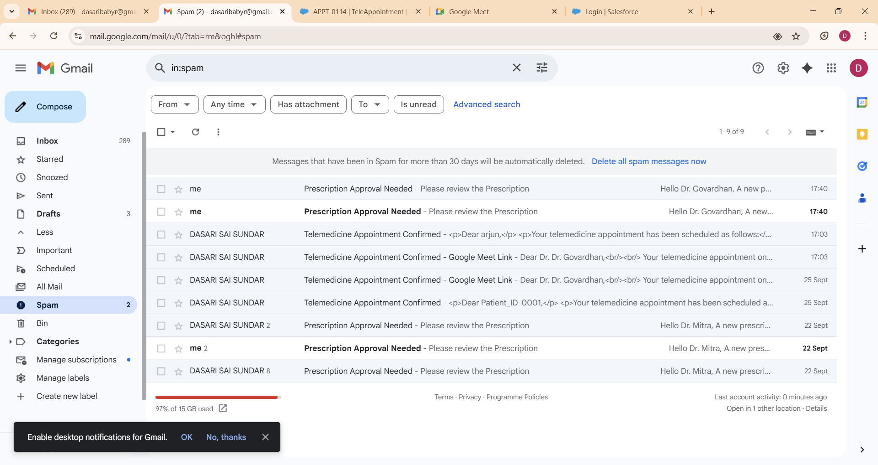

No mail can be updated in the patient mail.

Workflow Rules Validation 🡪Test Case2:

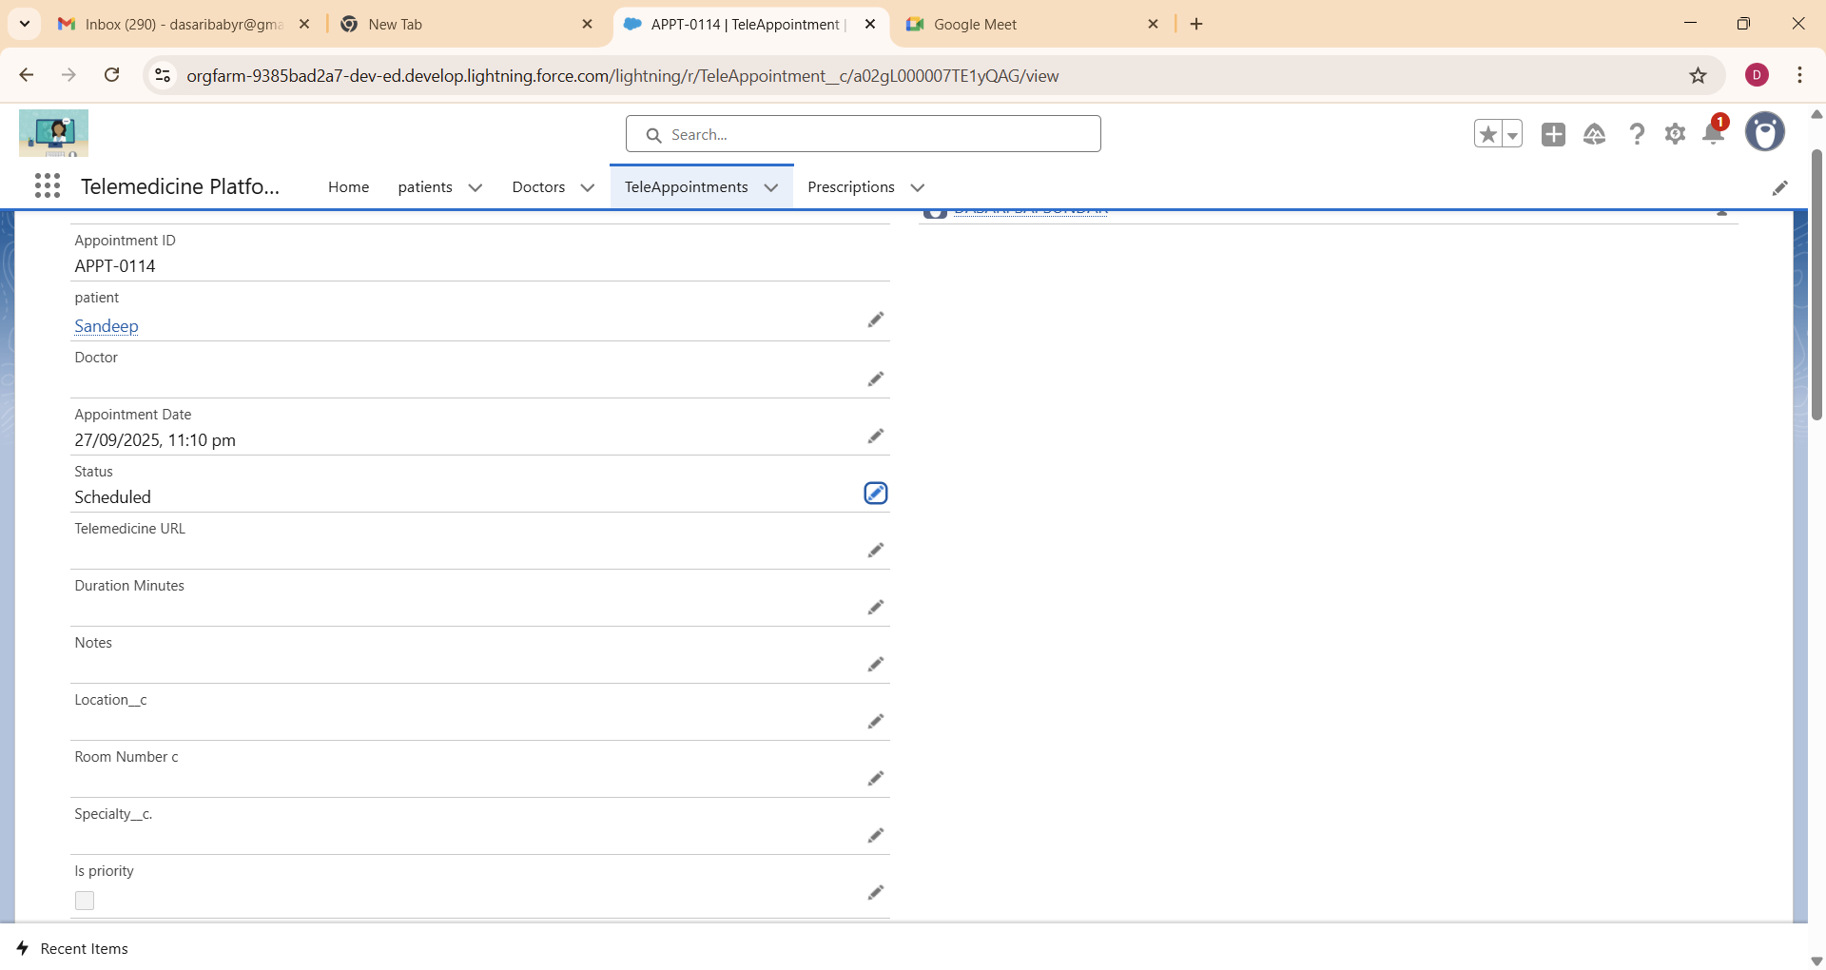

As the status is set as Scheduled and then got the mail.

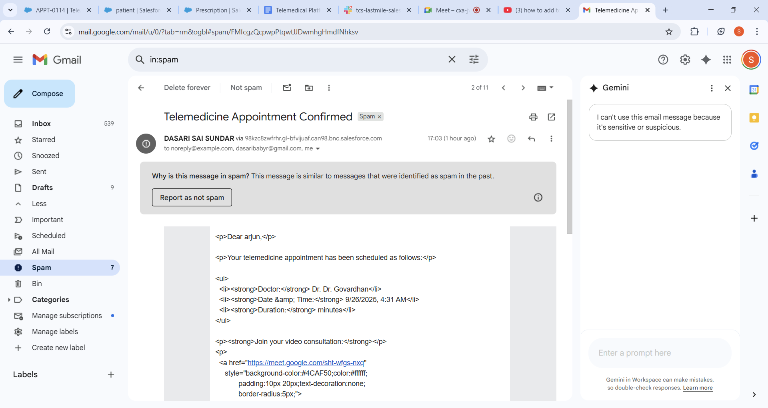

1. Process Builder:

In TeleAppointment Object when we select speciality we can get assigned the doctor according to the specialization.

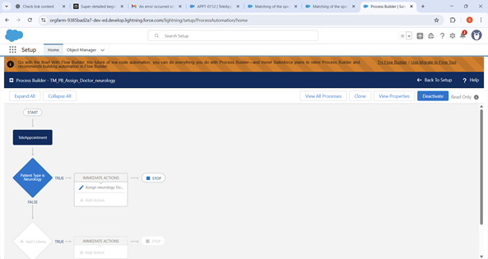

Process Builder 🡪Test case1:

Just give the specially of the problem.

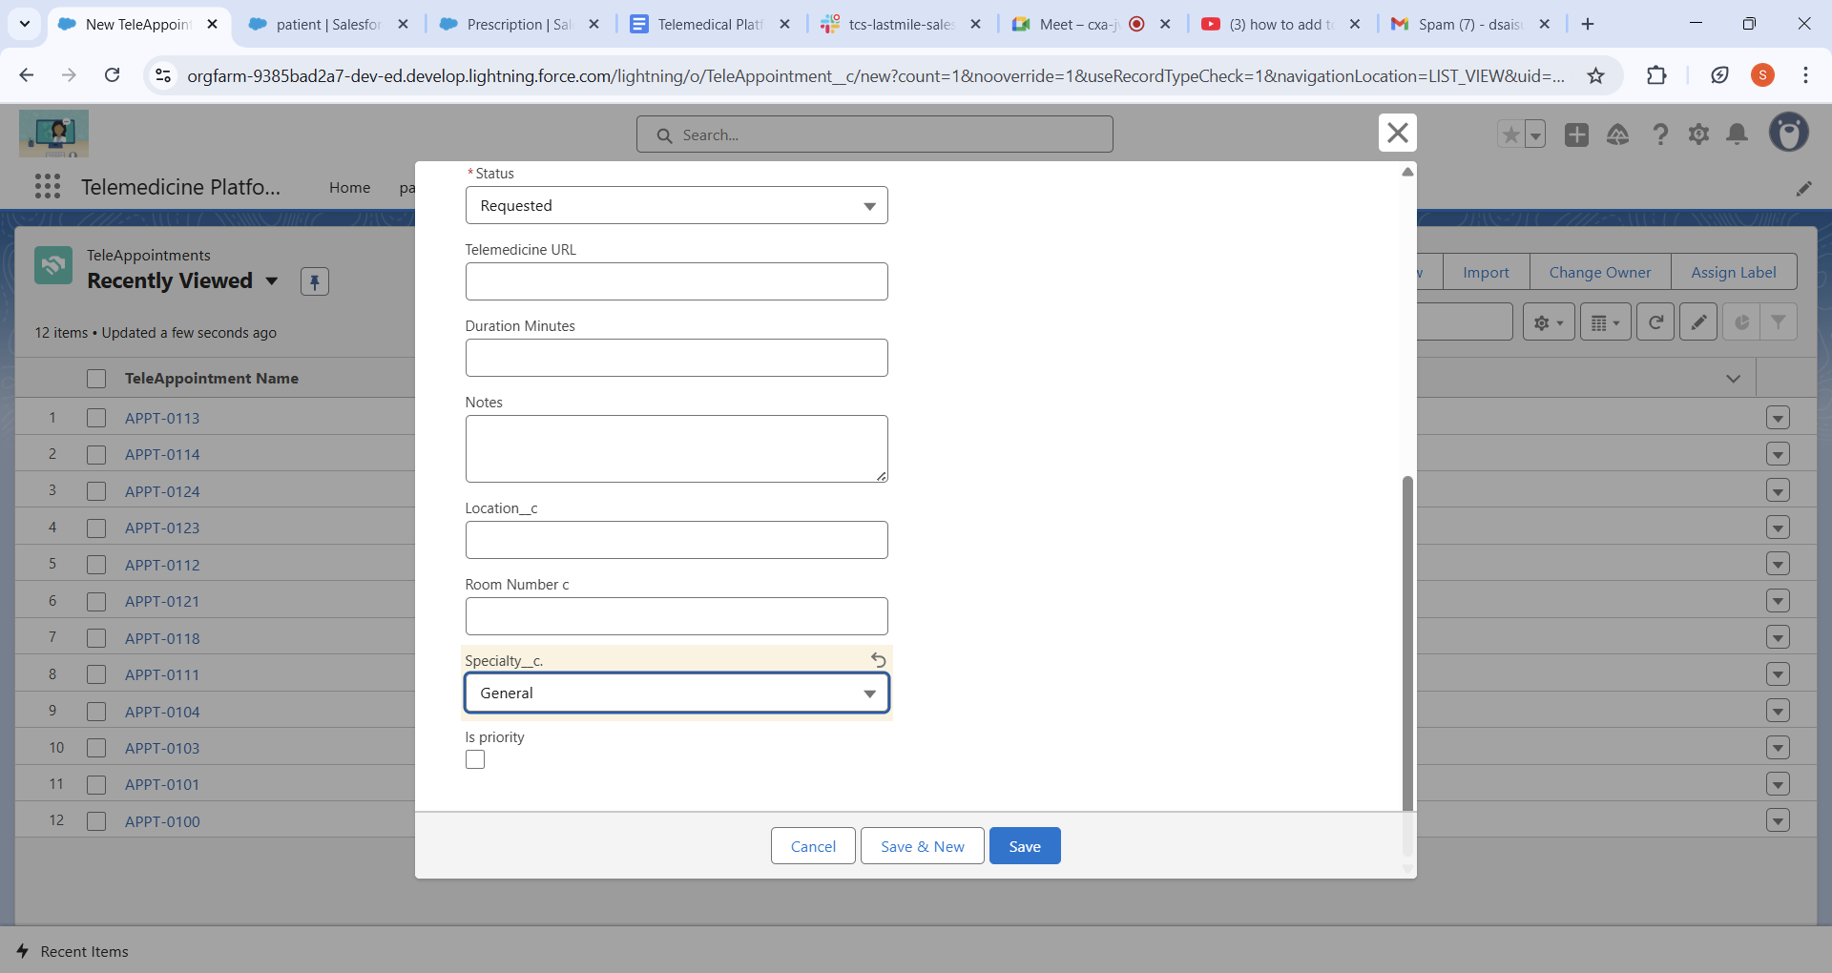

Got the doctor Assigned directly as I have given the general. Govardhan is assigned because his specialization is the General.

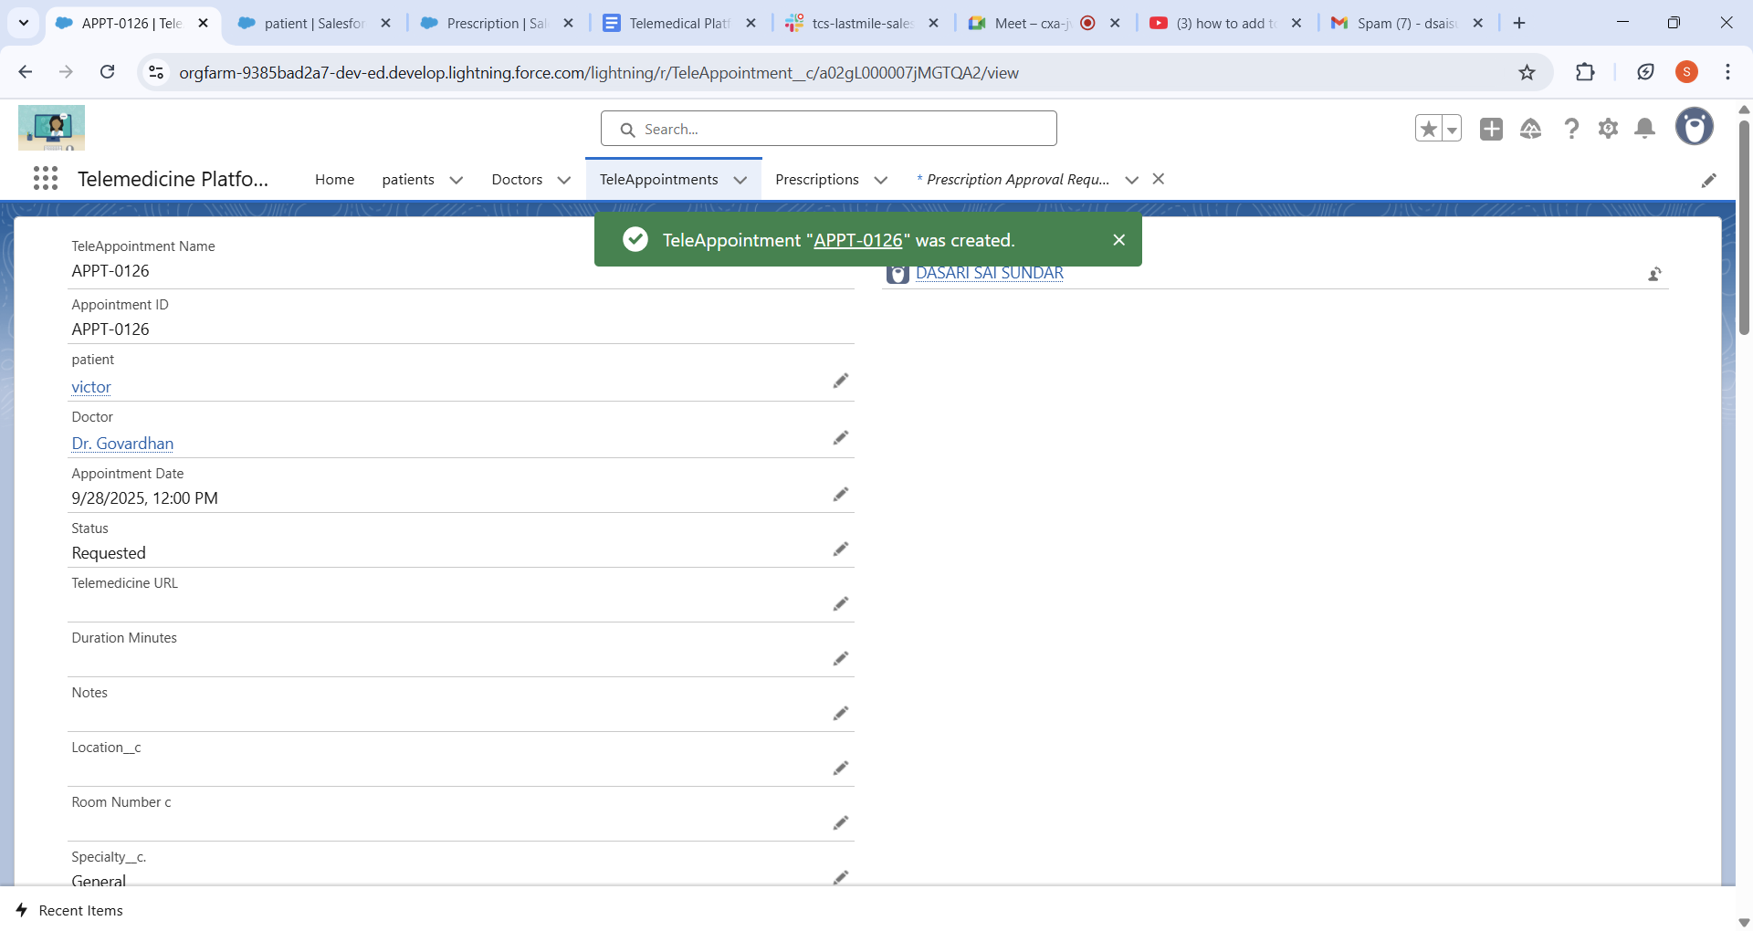

**Process Builder 🡪Test Case2:**

Just given the specially as the **CARDIOLOGY. Not Assigned the Doctor.**

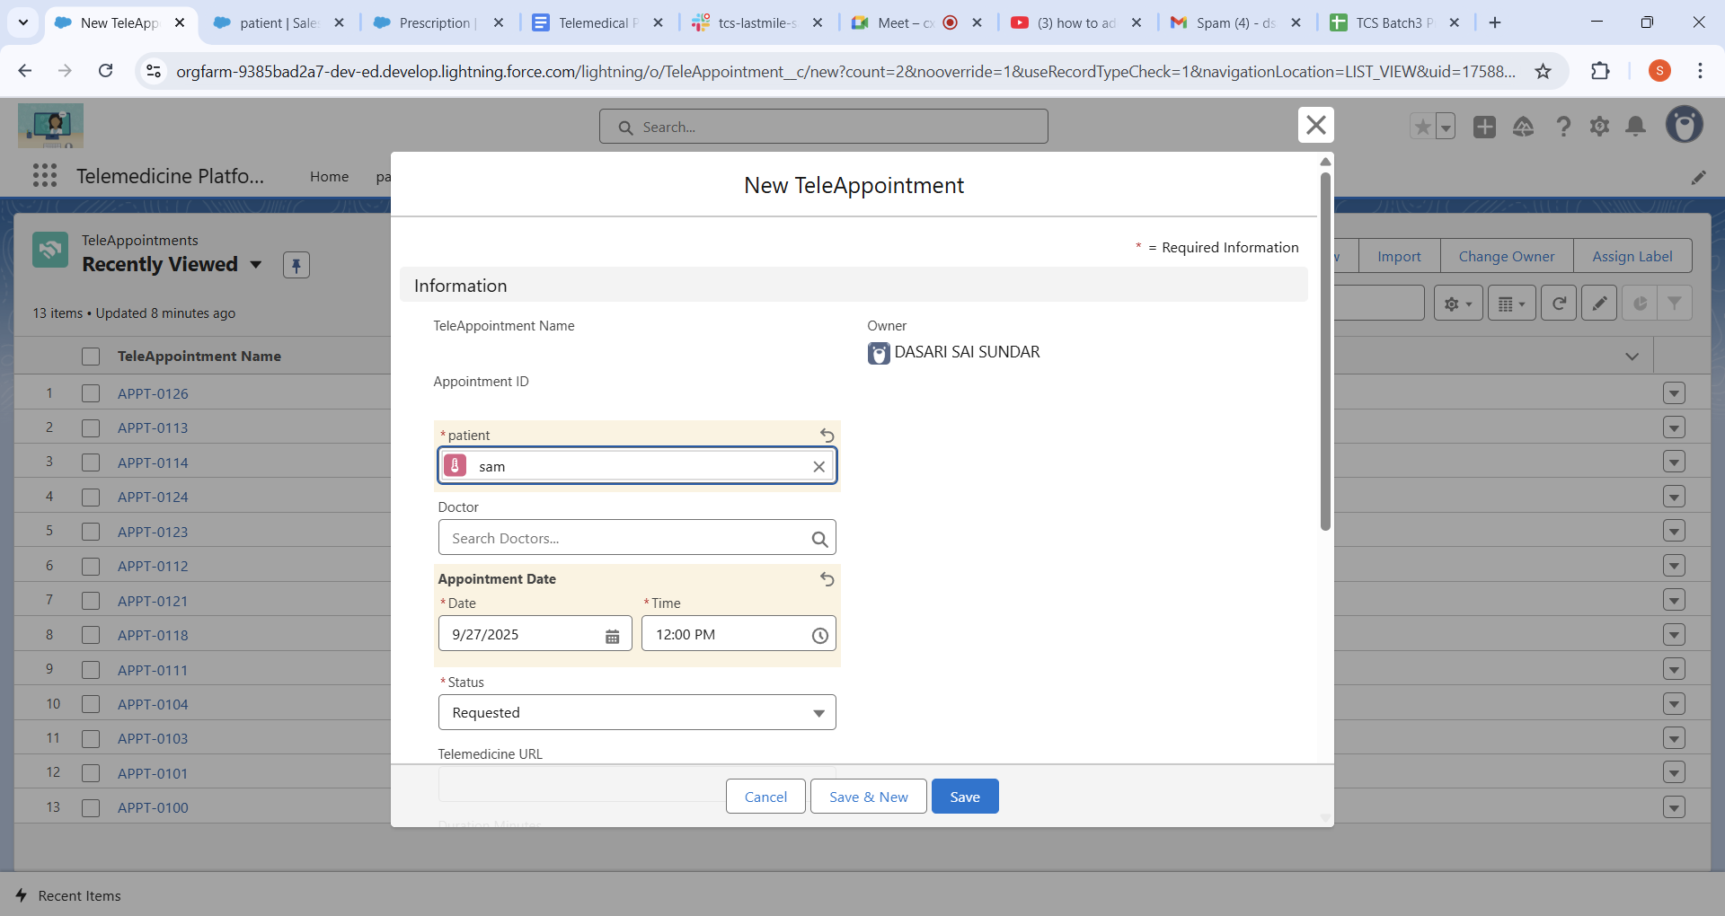

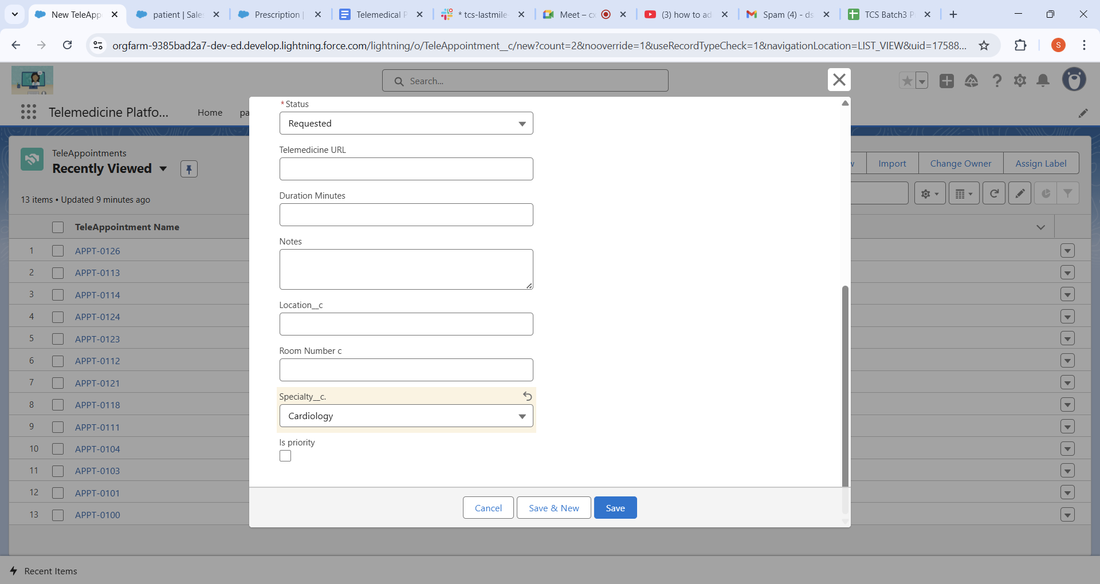

There we see the Mr. Shyam is Assigned successfully.(As the Shyam is Cardiology)

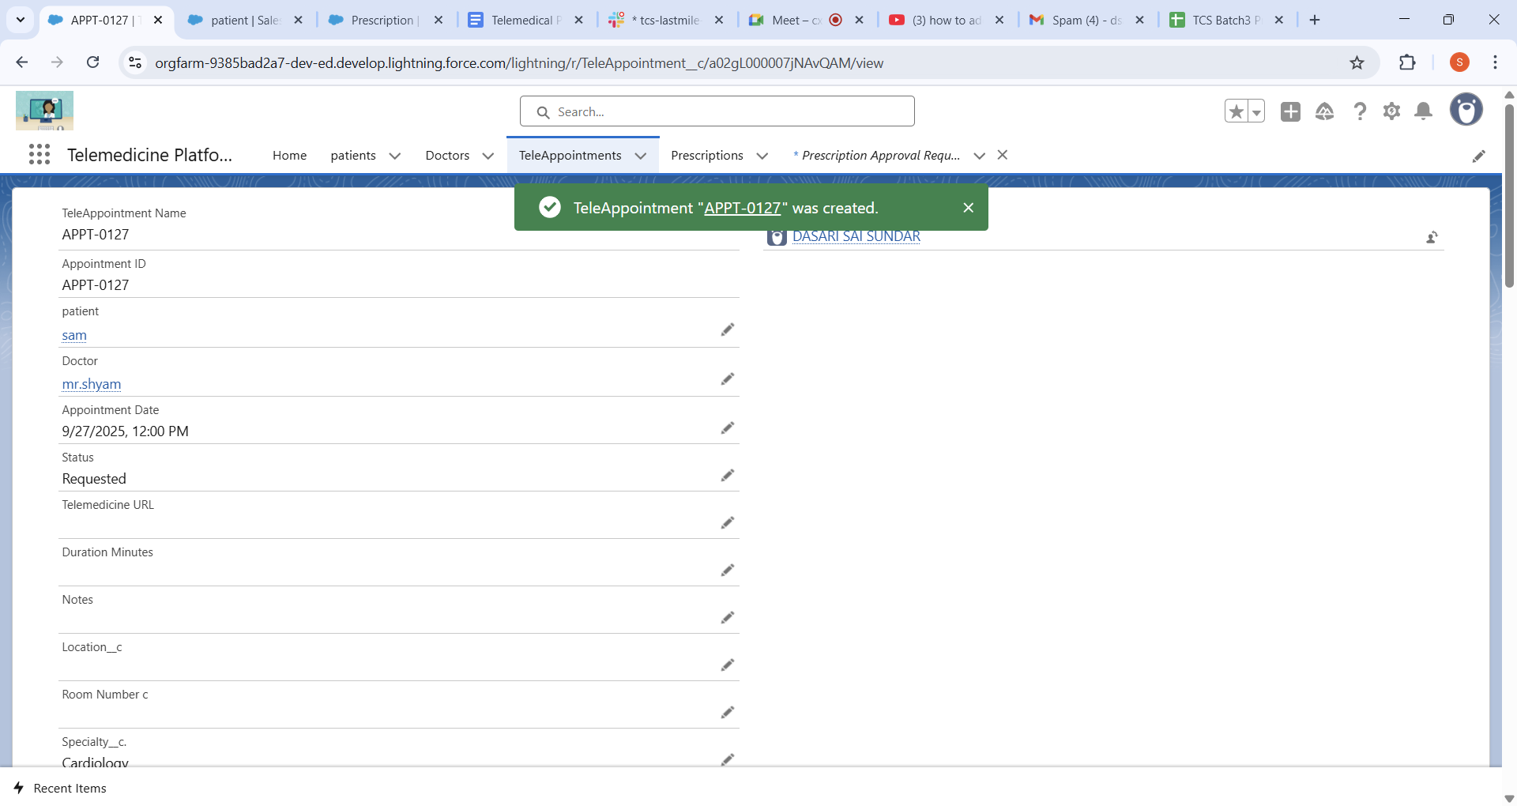

1. Approval Process:

This is the approval process for the prescription approval🡪it can be only Approved by the Doctor user.

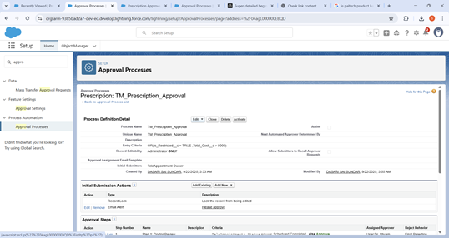

Created the Email templated and condition to send mail is total cost is more than the

5000.As the condition is achieved we should click the button SUBMIT FOR

APPROVAL.

Test Case1:In this case mail to Dr.govardhan as to approve the prescription.

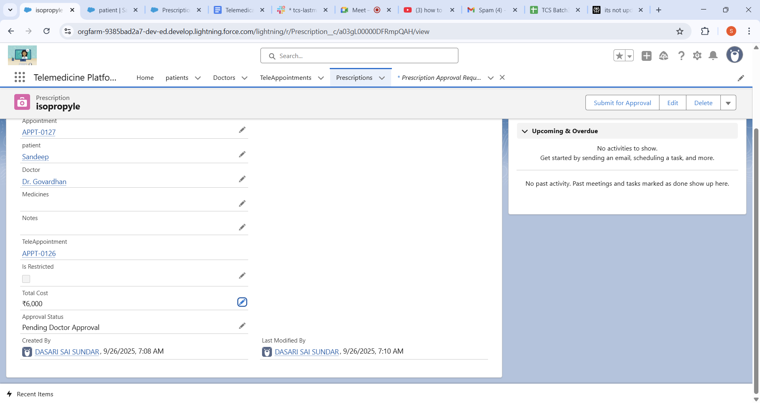

In the email box of the Doctor:

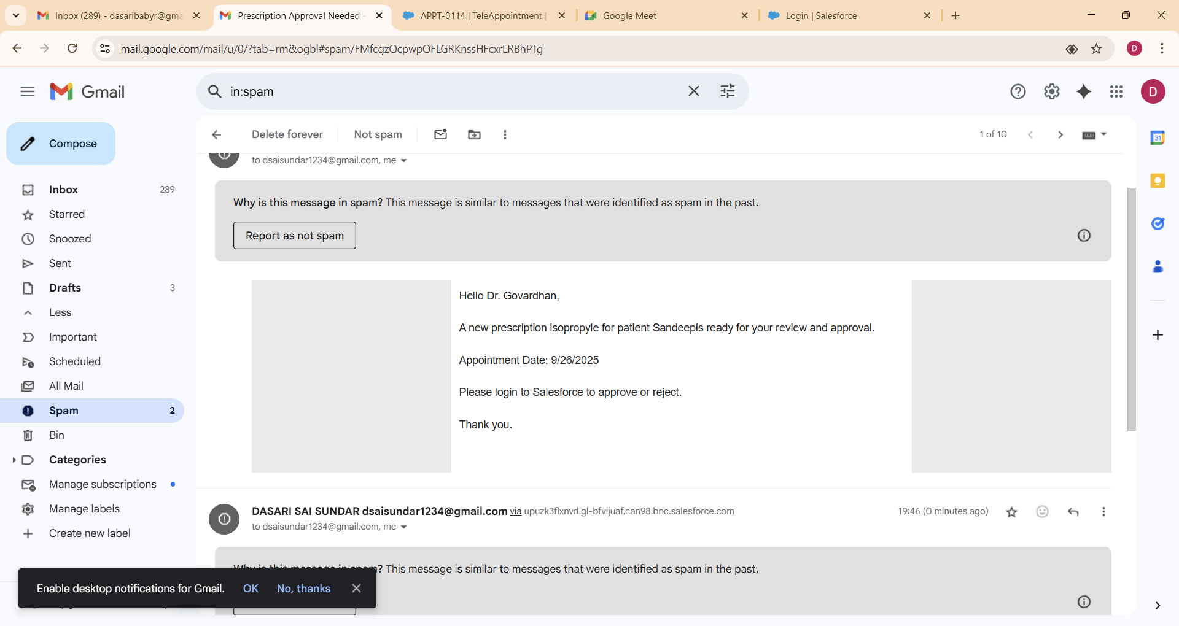

1. Lightning Web Component:

Here I have created AppointmentBooking,DoctorSchdule,PatientHistory,PrescriptionViewer etc..

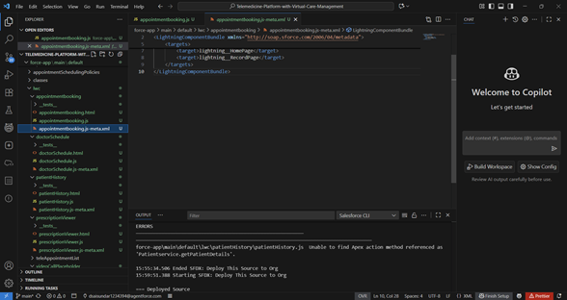

For our First Case: AppointmentBooking LWC is created and deployed successfully.

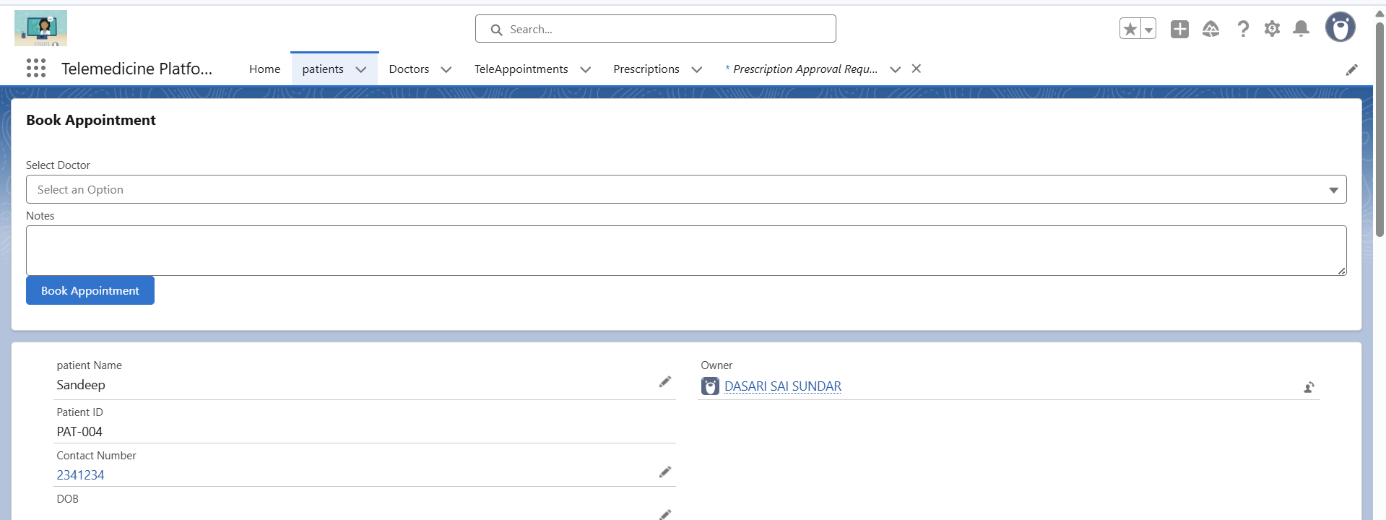

Whenever opened the patient Object in the platform we can see the Appointment Booking

Lwc with the Doctor name specialization and after clicking we can directly navigate to

the Teleappointment and the Mail is send to the Both Doctor and patient.

Test case1:Appointment successful with the Sandeep and doctor Mithra.

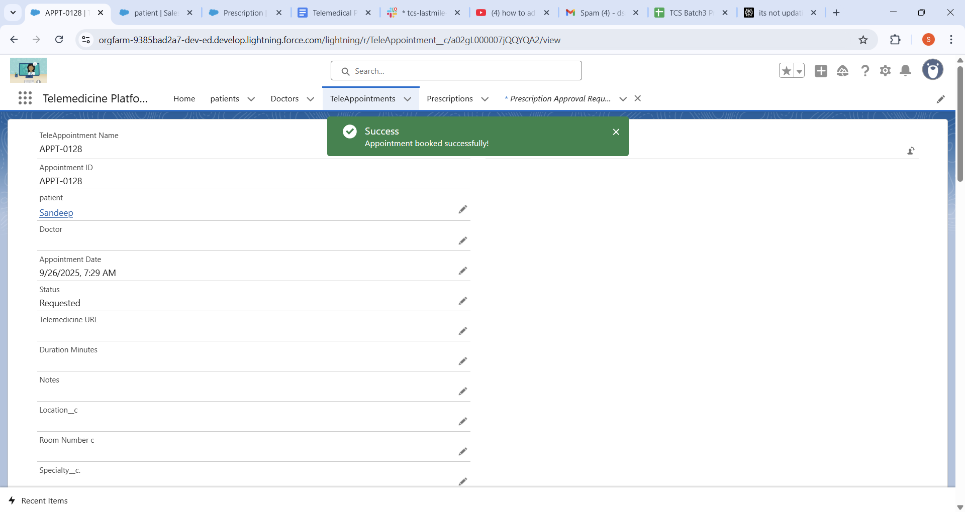

Here is the mail to be sent to Dr. Mitra:



Here is the mail for the patient (Sandeep):

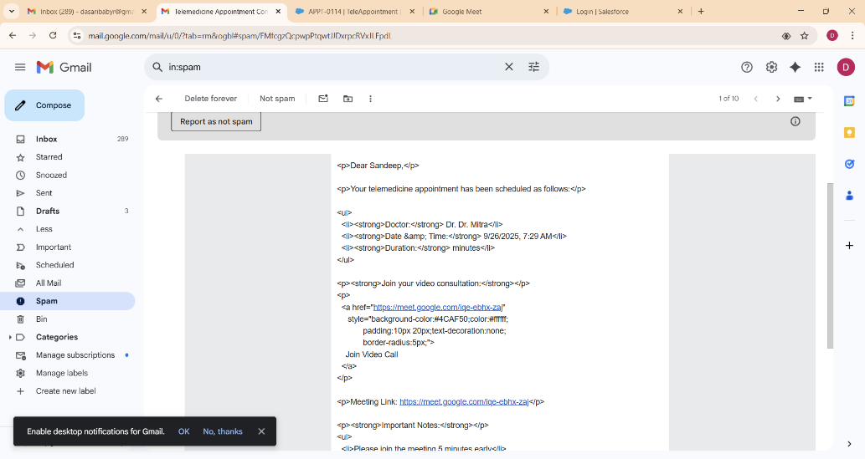

1. Import the Data from the Excel:

Created the Data of a Patient in the Word and save it in the .csv

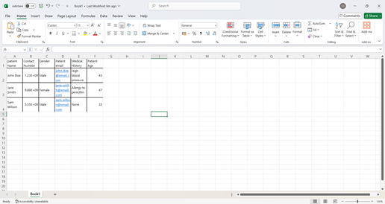

Test Case1-Success Jane Smith Fetched to the Telemedical platform to the Patient.

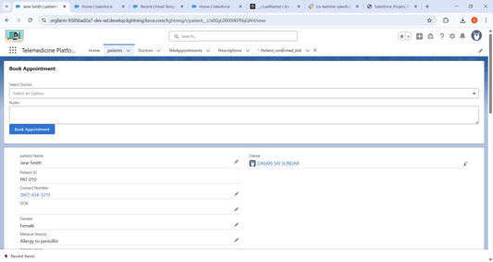

Test Case2🡪John Doe is fetched to the Patients data.

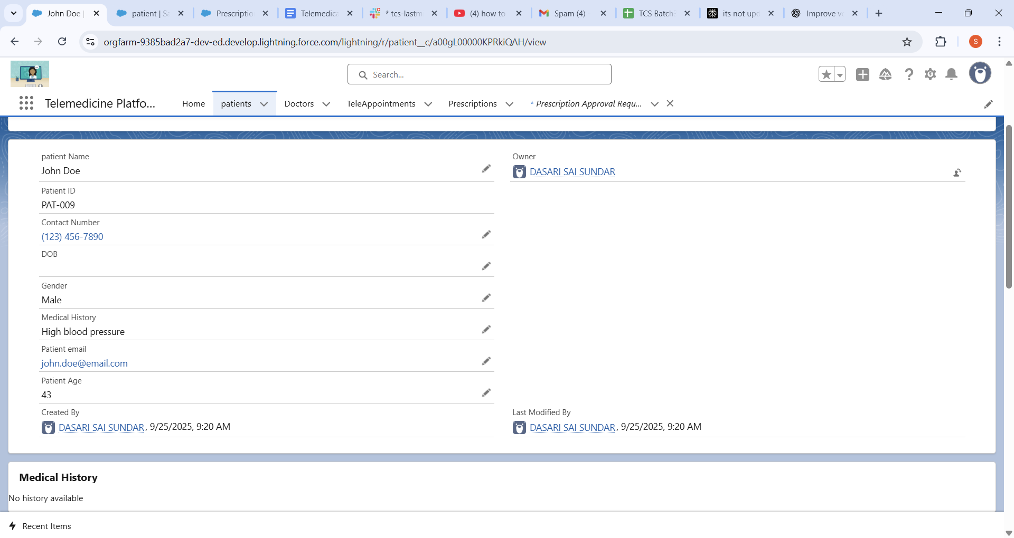

1. Duplicate Rules:

Created the duplicate rule with the Matching rule with Email.

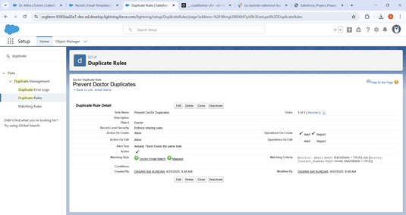

Duplicate Rules 🡪Test Case1🡪As we same email is given then the Warning may appear as the same mail.

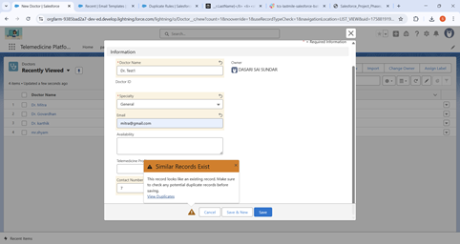

Duplicate Rules 🡪Test Case2🡪As we same email is given then the Warning may appear as the same mail.

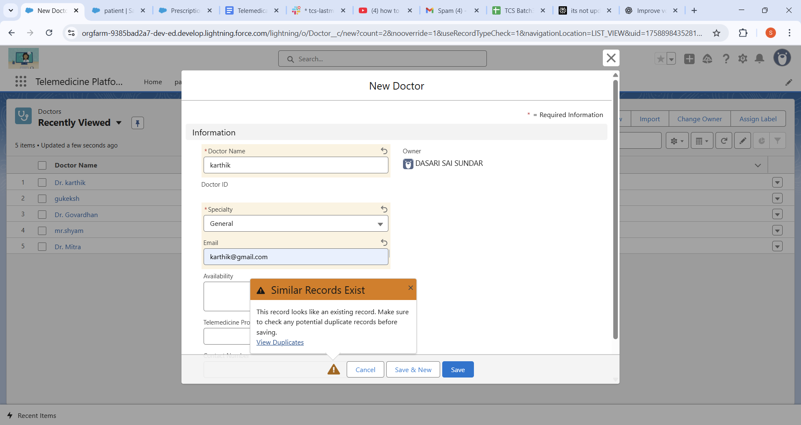

1. Login IP Ranges:

Enter a Start IP Address and an End IP Address that define your organization’s trusted network  range covers all IP addresses from 103.155.31.0 up to 103.155.31.255.

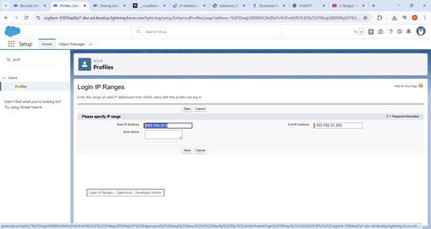

Login IP Ranges🡪 Testcase1:from my hostel no problem to login

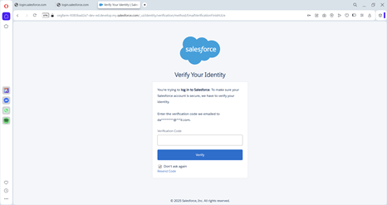

* From my friends home its not opening

